**Section 8 - The Alfa Romeo Experiment**

**Section 8.1 - Alfa Romeo's Projects**

The primary contact between Alfa Romeo and NSU dates back to 1962, and the engineers from the two companies frequently traded data whereas attaching the Wankel’s primary issue: the toughness of the rotor’s apex seals. As mentioned, these significant components of the Wankel motor plan are subjected to extraordinary changes in temperature and pushed innovation of the 1960s past its limits.

In the late 60's, the Alfa Romeo organisation began experimentation in a department or sub-section of their company, where two cars were used as subjects for the work of the rotary like motor. A **Convertible (Alpha Romeo Spider)** was fitted with a single-rotor 500cc motor producing 65HP and a **1750 Cantina** prepared with a bi-rotor 1000cc motor producing 130 HP.

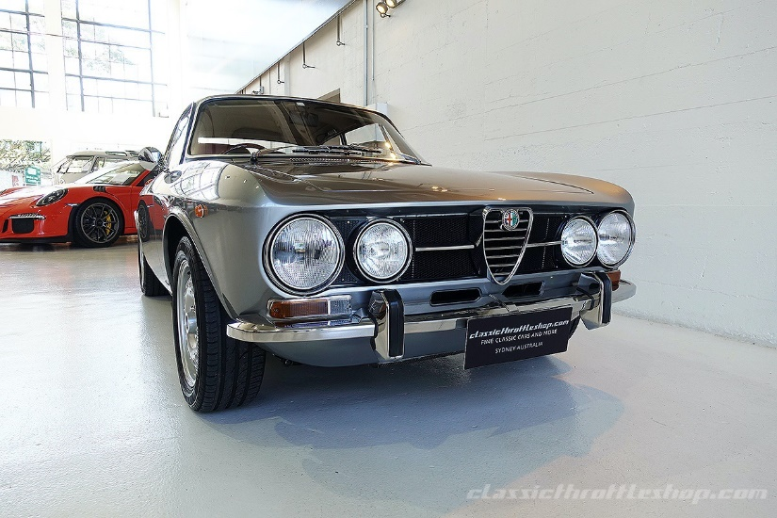

*Figure 1 - 1750 Cantina*

[*Image Source*](https://classicthrottleshop.com/1970-alfa-romeo-1750-grigio-medio-metallic/)

The rotational motors, for both cars, were attached to a typical production line gearbox of. The **1750 Cantina’s** gearbox is still connected to the motor even today.

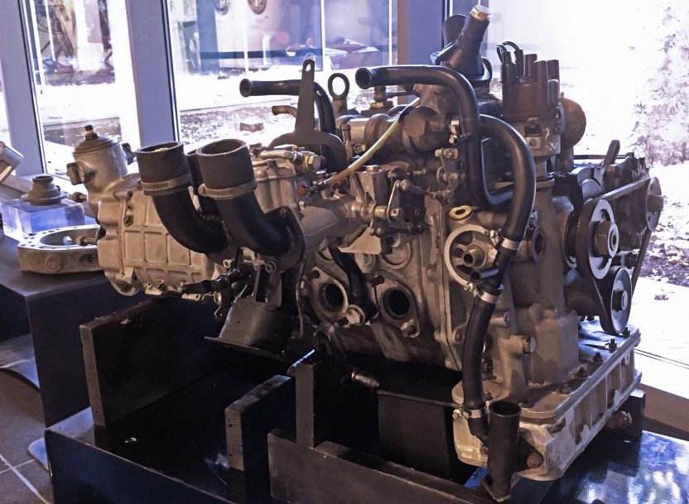

*Figure 2 - The Alfa Romeo Bi-Rotor Prototype Engine*

Both cars did not survive till the end of the experimental program. The experimental engines were taken away and stored as displayed in *figure 2.* Furthermore, both cars were crushed. Moreover, at this time Alfa Romeo was a small company and the budget allocated to the project was limited, alongside a small group of engineers and workers within the company. Therefore, even smaller teams or the number of researchers/workers for this project was very limited.

**Section 8.2 - History's Influence Production & Experimentation**

The content covered in *section 8.1*begs the question, whether history and there lack of advancements in technology had played a part in the limited life of the rotary engine.

Furthermore, would we still have rotary engines if test and work on such a motor had continued?

Potentially the rotary engine itself was a discovery made too early for society, and hence, there was not enough time, resources and man power given to the evolution of the motor.

The limited human and material resources of Alfa Romeo is an example of this. Therefore, such an influence had dedicated the fall of the project.

Furthermore, there was no attempt, especially during the 1960's-1970's (where environmental concern was nowhere near as severe or intense as presently) to research in a re-worked rotary design that does not have a large environmental impact (during specifically the time of the rotaries initial invention).

**Section 8.2.1 - The Oil Crisis**

Work on fuel injection and electronic engine management systems became a significant issue since, the USA enacted anti-pollution laws however, such work was also limited and impacted due to the oil crisis of late 1973. Hence, reducing further the efforts and resources available to be employed towards projects, experiments and research on the motor.

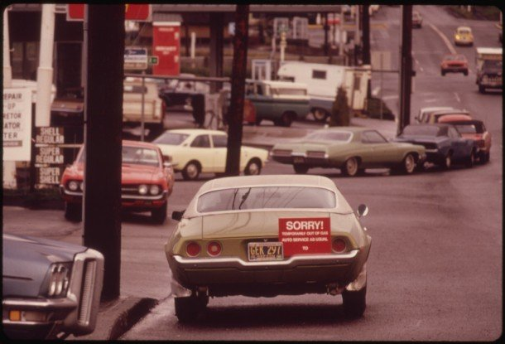

*Figure 3 - Oil Embargo of 1973*

[*Image Source*](https://www.thetruthaboutcars.com/2013/10/the-1973-oil-crisis-40-years-later/)

Prior to the events of 1973 and the oil embargo, the most popular cars within the US were large engine, such as V8s. However, most motorists sought out smaller, more fuel-efficient offerings from Europe and Japan due to this event.

Therefore, even from the Japanese market, most of the public turned away from, and production of, the rotary engine vehicles were not as popular.

However, it is arguable that some of the research and other purposes of the rotary engine (such as listed in *section 7*) were born due to the rise in the environmental concerns within society. Finally, forcing engineering with this engine to turn in a whole new direction of hybridism.

**References:**

[1] - Licata, M., 2019. *The Alfa Romeo Experimental Wankel Engine Programme*. [online] Driven To Write. Available at: <https://driventowrite.com/2019/08/06/the-alfa-romeo-experimental-wankel-engine-programme/> [Accessed 24 May 2021].

[2] - Aubernon, C., 2013. *The 1973 Oil Crisis: 40 Years Later - The Truth About Cars*. [online] The Truth About Cars. Available at: <https://www.thetruthaboutcars.com/2013/10/the-1973-oil-crisis-40-years-later/> [Accessed 24 May 2021].